Bán Zsigmond Calvinistic Bilingual Primary School, Primary School of Art and Kindergarten

2 Fő Street in Tiszafüred

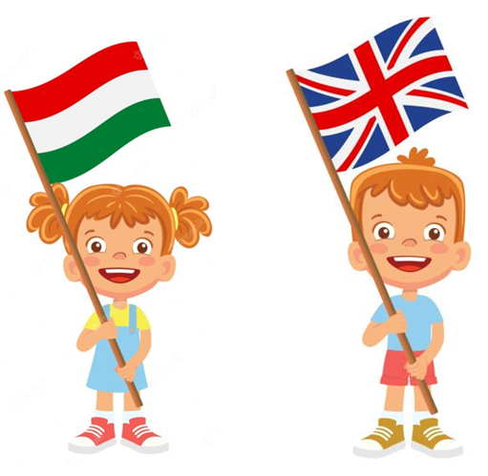

REPORT

English language education

Session 2022/23

- Ongoing from September:
- ALF - programme: in our school we use the ALF online assessment programme, which allows students to solve homework or assessments prepared by their teachers in the online space. Each series of tests measures students' knowledge of a particular subject area through different types of tasks. At the end of the task, students can see their scores and percentages for themselves. The programme is also suitable for classroom practice and can be used on interactive whiteboards, computers or tablets.

- Choir. The choir provides a programme of music to complement the student services on various church festivals. The pupils of the two-language sections also sing in English for the celebrations.

- Preparation for English language examinations.

- August - September:
- Decorating classrooms for the new school year. Posters, posters and decorations in English and Hungarian will be displayed in the classrooms of the bilingual classes.
- Assignment of upper school pupils to the ALF programme. Pupils get their own access code consisting of a username and a password. Through this system, pupils receive homework or complete an online assessment in English. It is also an excellent tool for classroom practice.
- Contact - and consult with our native speaker teacher.
- 13 September: Dutch students (two boys and one girl) arrived at our school in mid-September. The children speak English in addition to Dutch, so the boys in Years 1 and 3 settled easily into their classes, communicating easily in English with their peers. The 7th grade girl also started her studies in her own class and was taught in Hungarian by our English teacher Imre Szabó. During the semester and end-of-year exams, she took exams in English in some subjects. We hope that next academic year he will be able to pass the exams in Hungarian as well. The children will receive help with their studies from colleagues who speak English and from those who do. Fortunately, by the end of the school year, they have managed to integrate with their peers and have learned a few things in Hungarian.
- October:
- October 3: Our native speaker teacher, Cameil Christie, registered online for lessons from Washington State. Introductions were made by both the lector and the students.
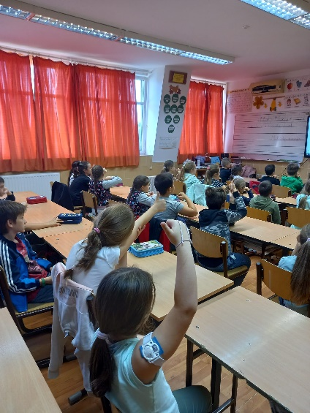
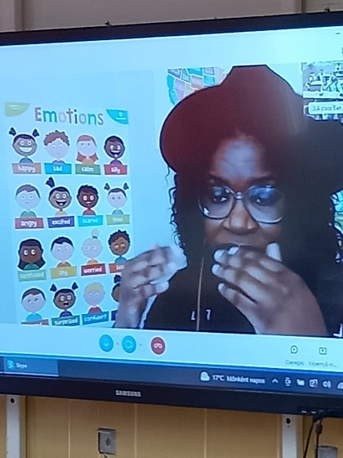

- November:
- 21 November: Also in the context of online lessons, our new mother tongue tutor Hannah-Sax Poole arrived to give English language lessons to bilingual students.

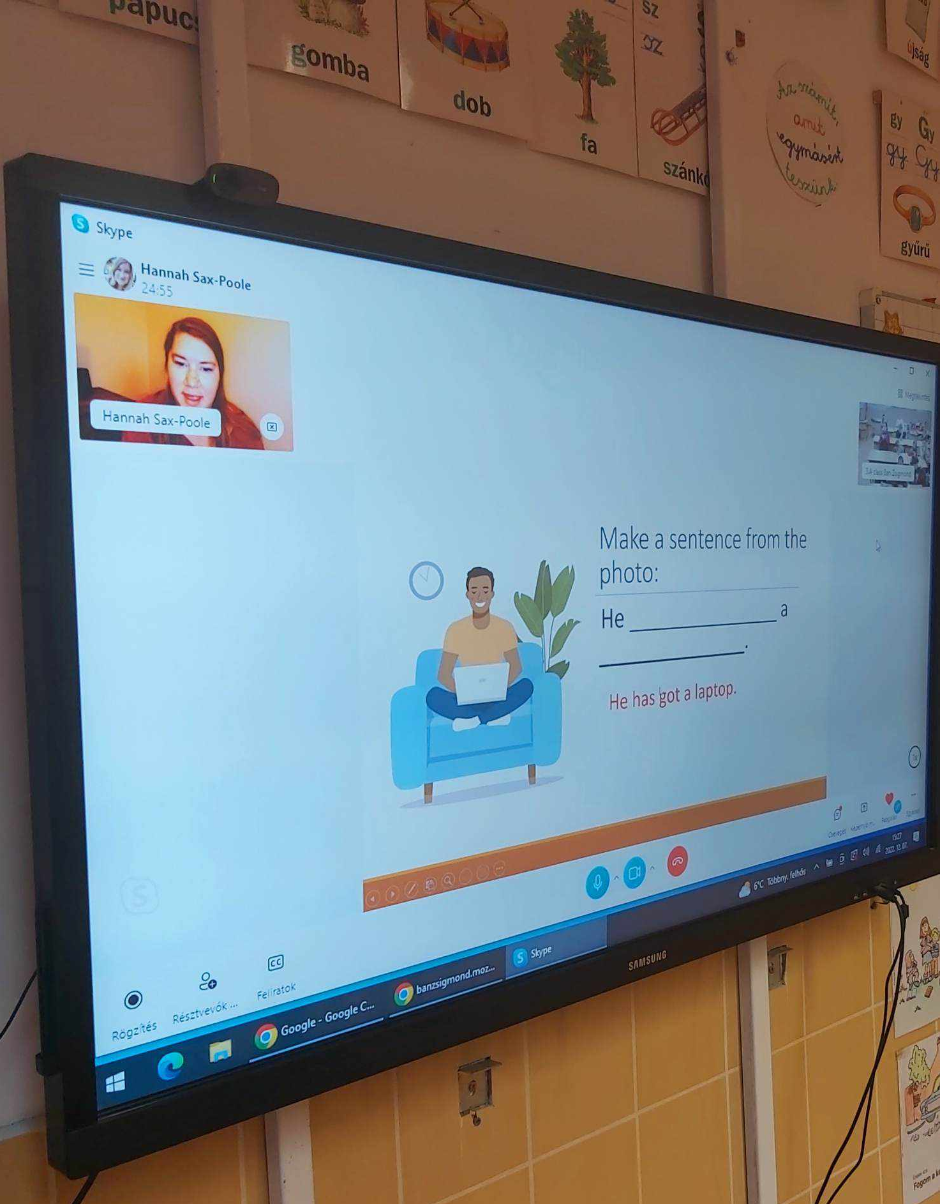
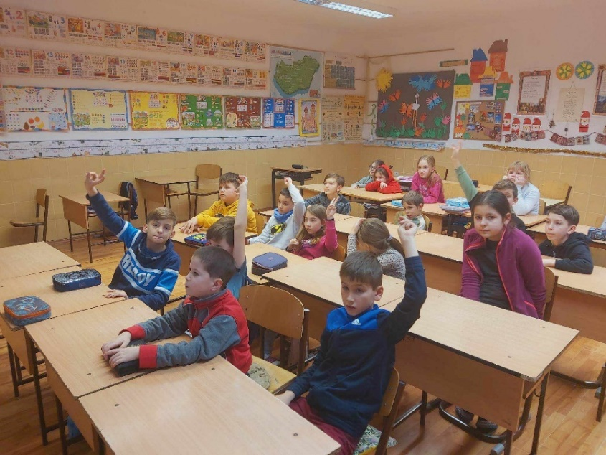

- November 27: On the first Sunday of Advent, our 3rd grade students served at the Calvin Community House. The 3rd and 2nd grade choir sang songs in Hungarian and English.
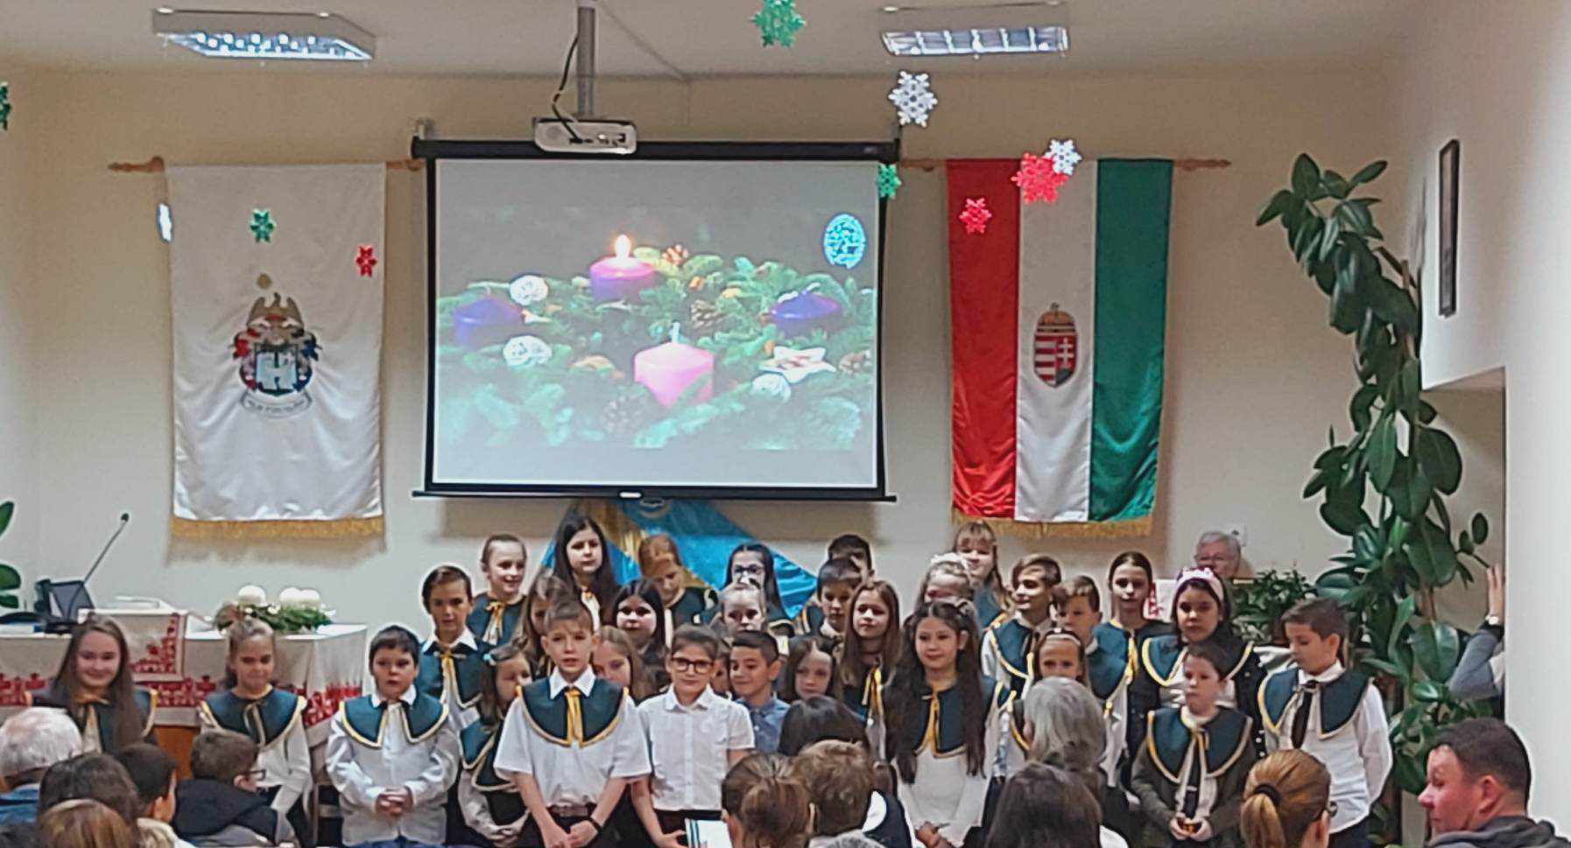

- December:
- December 18: City Advent celebration: the 5th grade of our school performed a festive show at the City Advent celebration in Tiszafüred, where the students also recited a Christmas poem in English.
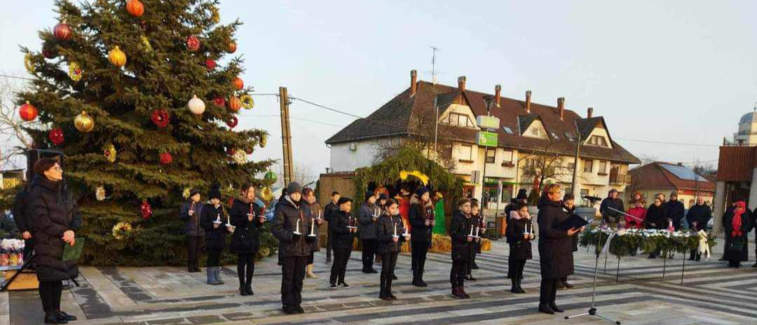

- 19-21 December: In the last English lessons before the winter break, we supplemented the current curriculum with various Christmas-themed quizzes and worksheets. We also taught Christmas songs in English with the lower school pupils.

- January:
- January is the semester for examinations in different subjects for each grade. English language examinations are given to the 6th and 8th graders. The topics of the exam are similar to the oral sections of each language exam, which are related to everyday life and focus on general communication skills. The exam is divided into three main parts: general introduction, topics/communication, description.
English is taught in a level-group structure, so the content of each item varies from group to group, depending on the level of the group.
- 23 January: Our native speaker teacher, Hannah-Sax Poole arrived from Chicago to Tiszafüred and continued teaching in person from 25 January. She has been teaching English in the general classes in addition to the bilingual classes. For her, communication in English is very important, so she tries to talk to the children in English as much as possible in class, as it is the language they have in common. In the lessons, she always uses playful and creative exercises to transfer new knowledge, which makes it easier to practise together.
- The pupils got to know the tutor. The pupils introduced themselves in English and shared some information about themselves and their interests. Hannah also told the children a lot about herself, her family and her home.

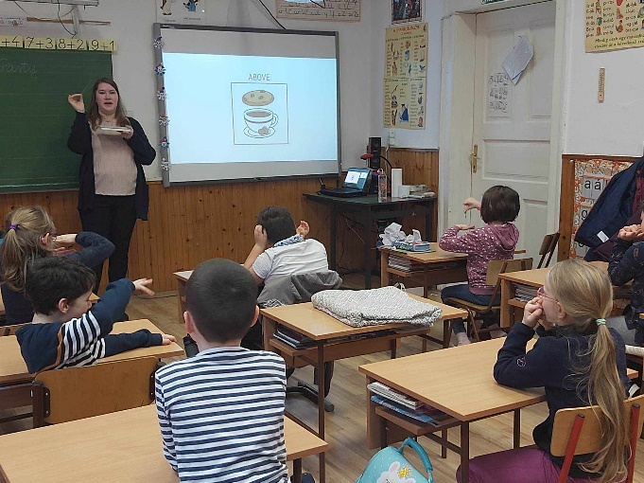
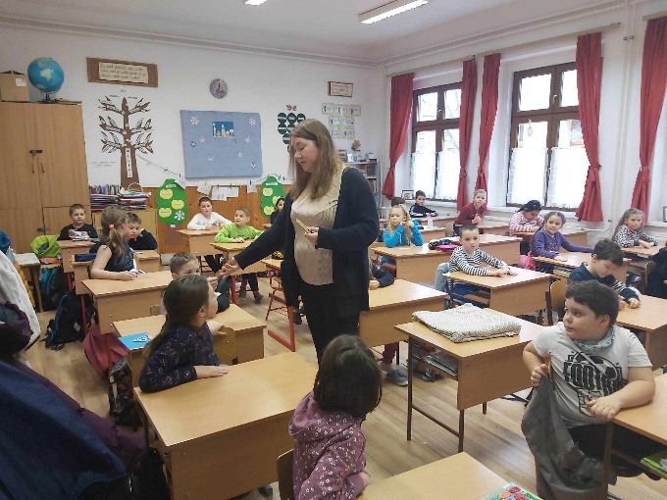

- February:
- 28 February: Pancake Day: the event, organised by our school, was an English language and skills competition, in which teams from our school and from schools in and around Tiszafüred participated. Applications were invited from pupils who love English and are interested in the traditions. The competition was called Pancake Day in Zsigmond Ban, inspired by Pancake Day / Shrove Tuesday, a tradition from England. This year the official date was 21 February, but in our school we held the competition on 28 February. As a preliminary task, the participating teams made pancake desserts, which were scored by the judges and eaten before the results were announced. The competition was made even more colourful by the students' imaginative costumes. The pupils competed in groups of 4 in theoretical and practical exercises. The main theme was Pancake Day and pancake-making. The theoretical exercises were in English and included crosswords, quizzes and recipe puzzles. Teachers from the invited schools were involved in the evaluation of the tasks. The pupils performed well. One of the two teams of eighth-graders from our school came third in the competition. It is also worth mentioning that the third-grade team from the dual language class took part in the competition out of competition, but would have come second on the basis of the scores.

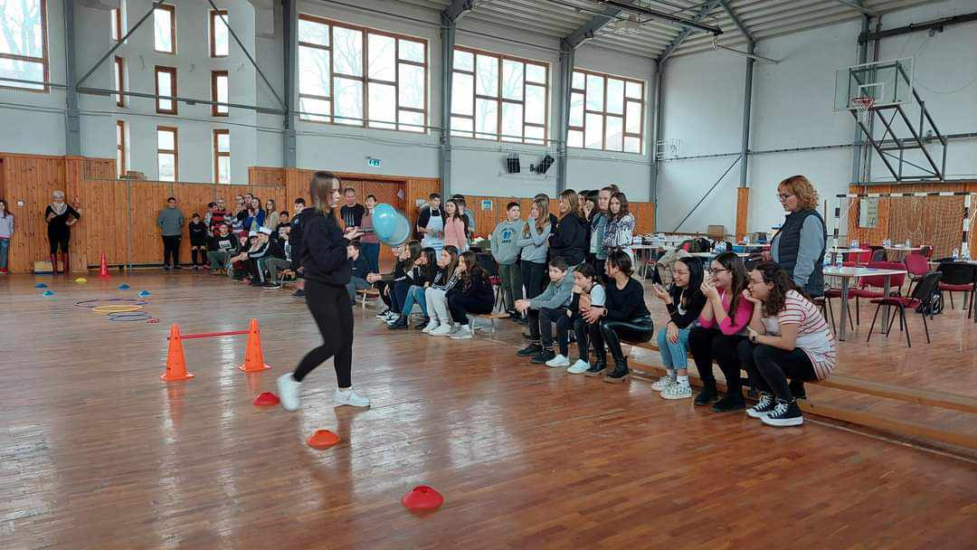
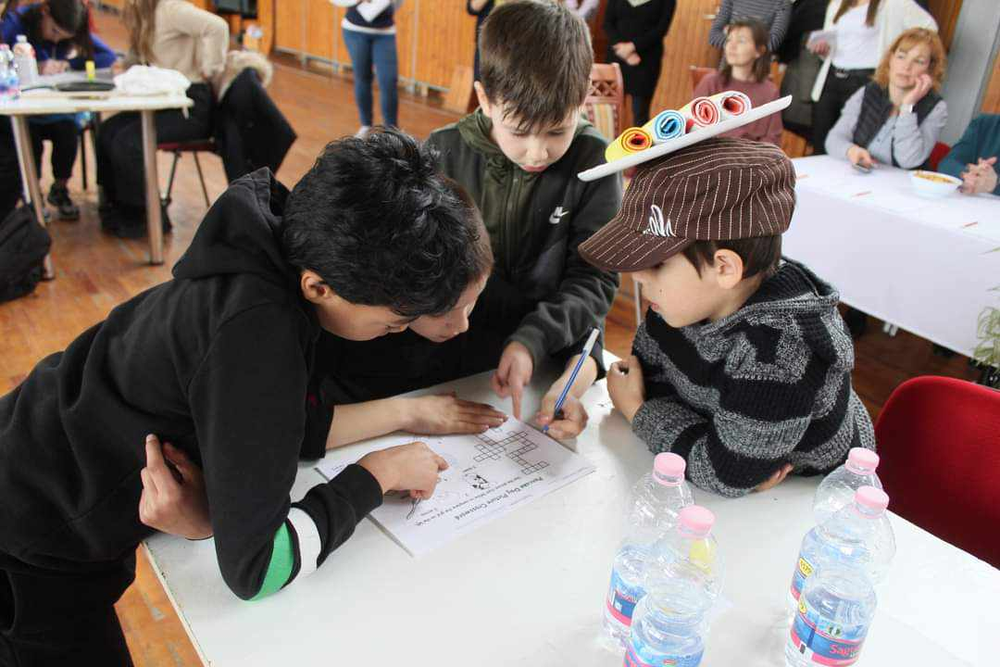
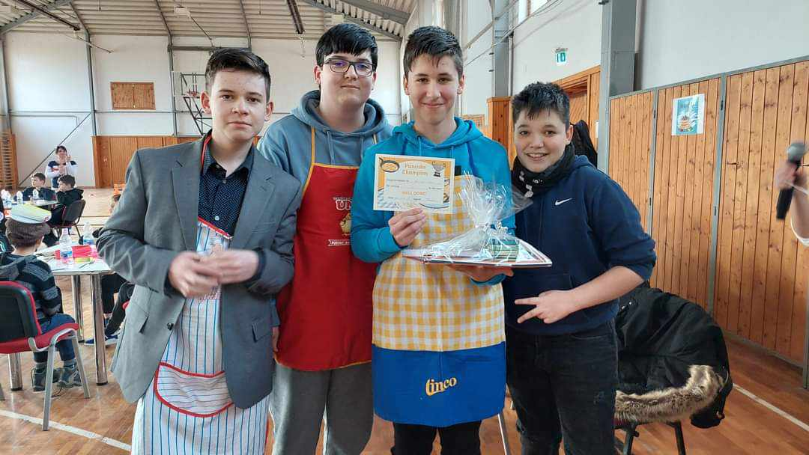
Pancake Day:

- March:
- 23 March: 4 teachers from our school participated in a professional forum organised by the Kassai Úti Hungarian-English Bilingual Primary School in Szolnok.
- April:
- In April, during the English lessons before the spring break, we did some activities in English related to the Easter holiday.
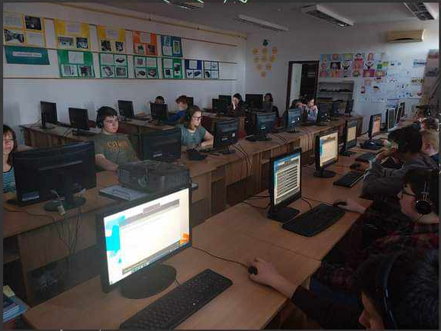
- 21 April: National online English competition. Pupils could compete in two age groups: grades 5-6 and grades 7-8. The test consisted of a variety of task types that students had to solve in a given time. Pupils were informed of their results by means of their access codes. 20 schools entered the competition with 209 pupils.

- May:
- The end-of-year oral exams have started. As in the mid-term exams, the English language exams are now being held for 6th and 8th grade students.
- The language preparation courses for pupils who took the Origo Junior exam on 13 June have started.
- June:
- 13 June: Junior language exam: 24 students (grades 6-8) from our school took the Origo Junior English exam, which consisted of a written and an oral part. The requirements for the Junior exam were at level A2 of the CEFR. The tasks measured all four language skills. The students achieved good results in the exam.

- Summer camps:
- 10 - 14 July 2023: Healthy Lifestyle Camp
The Healthy Lifestyle Camp was held in our school from 10 to 14 July 2023. The main aim of the camp was to teach children the basics of healthy lifestyle, both in the areas of nutrition and physical activity, and to improve their English language skills. Each morning started with gymnastics, zumba or dance. Mornings were spent doing creative exercises or puzzles in English. The activities were related to healthy living. Some mornings we had extra-curricular activities. On Tuesday we visited a local gym and on Wednesday and Friday we went to a playground. The afternoons were spent in the gym, where the children could play, dance, talk, draw and even play ball games.
Several times during the week, we prepared snack made from fruit or vegetables. On Monday we made a vegetable salad, on Tuesday we made a refreshing smoothie with different fruits (bananas, blueberries, pineapple, cantaloupe, cherries), on Wednesday and Thursday we had muesli and oatmeal with yoghurt and delicious fruit. We were delighted that the camp brought together several age groups.
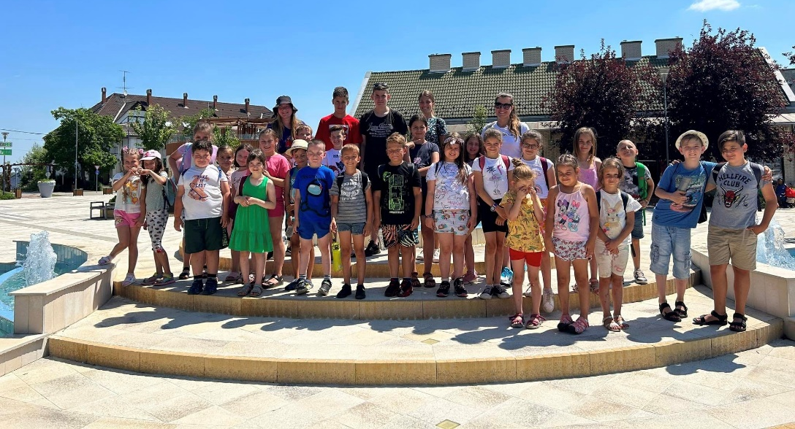

- 24 - 28 July 2023: English Freshers' Camp
Our school hosted the English Freshers' Camp from 24 to 28 July 2023 for our prospective first-graders who will start their bilingual studies in September.
The main aim of the camp was for the children to get to know each other and their future teachers, and to learn the basics of the English language.
Every day a new topic was explored in a playful way. We learned new words and phrases through songs, sayings and playful exercises. By the end of the week, we had learned to introduce ourselves in English, count, name different colours, vegetables, fruits, animals and toys.
Some afternoons we made our own souvenirs that related to the theme of the day. In addition to playful learning, we played a lot of games together.
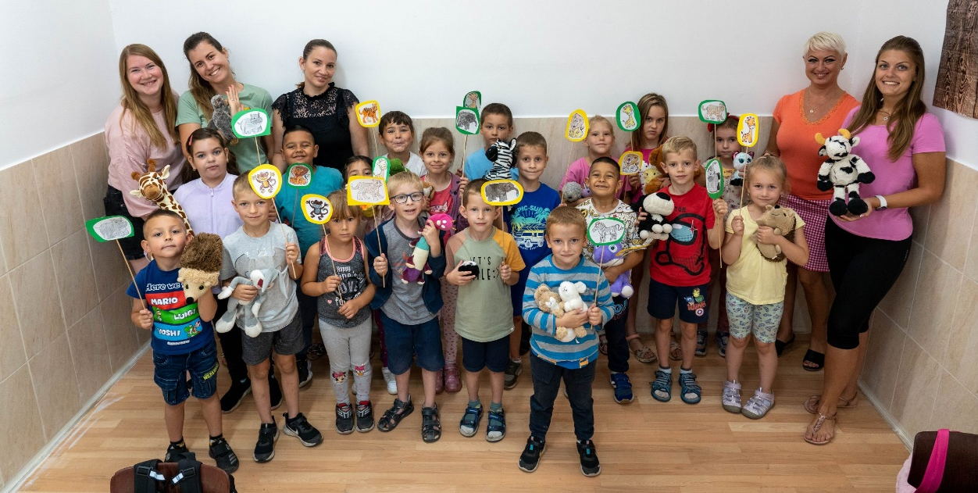

- 31 July - 4 August 2023: Reading and English language camp
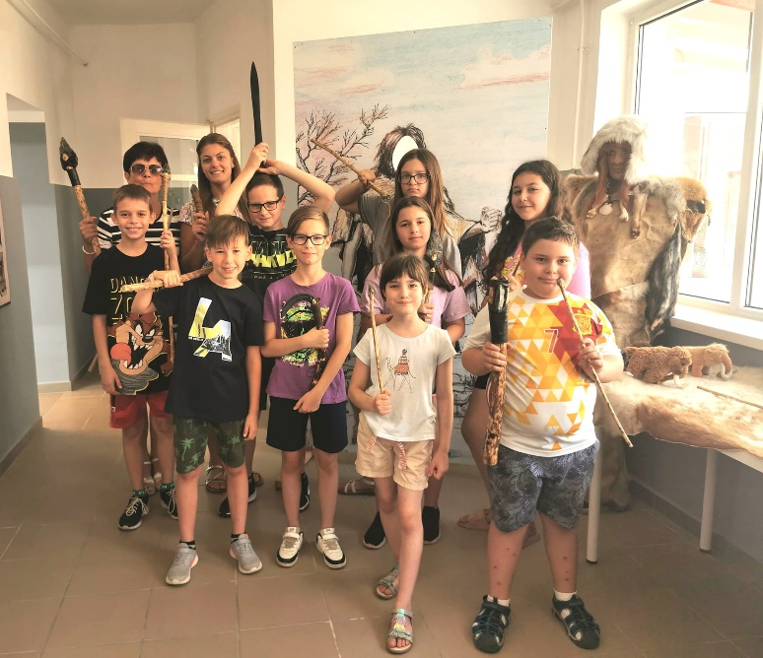
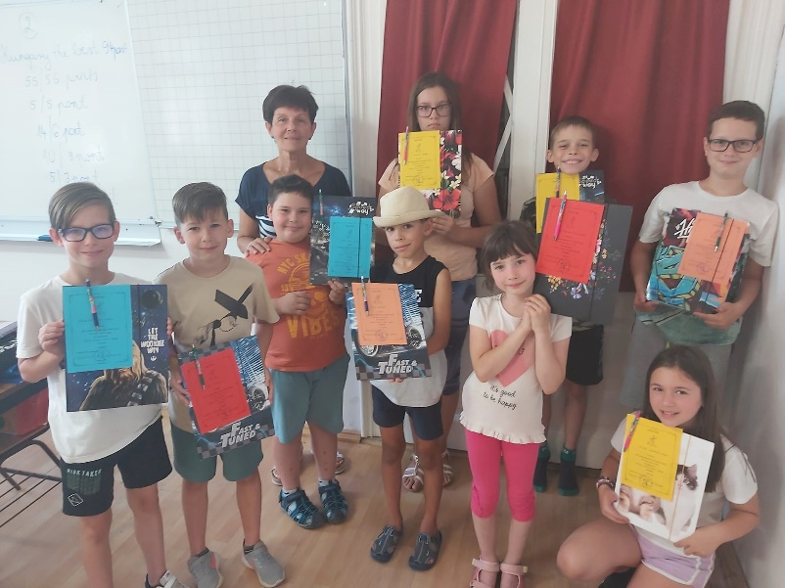
During the five days of the reading and English camp, we tried to learn literary knowledge in Hungarian and English through playful games and shared reading experiences. We planted the seeds of a love of reading and the importance of using and learning English in the children who participated and hope that reading and language learning will become part of their everyday lives.

