Bán Zsigmond Calvinistic Bilingual Primary School, Primary School of Art and Kindergarten

2 Fő Street, Tiszafüred
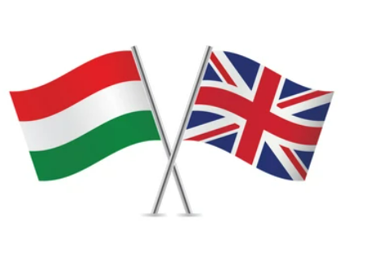

REPORT

English language education

Session 2021/2022

Ongoing from September:
- ALF programme: in our school we use the ALF online assessment programme, which allows students to solve homework or assessments prepared by their teachers in the online space. Each series of tests measures students' knowledge of a particular subject area through different types of tasks. At the end of the task, students can see their own scores and percentages. The programme is also suitable for classroom practice and it can also be used on interactive whiteboards, computers or tablets.

- Examination preparation in English: continuous preparation for the mid-term and end-term English language examinations in grades 6 and 8.

- Erasmus application:
- Our school works with external partners in the framework of the Erasmus programme, in cooperation with Croatia, Northern Ireland and Turkey, as well as with schools applying from these countries. The aim of the competition is to promote international cooperation between different schools and countries. The main theme of the programme is the protection of the Earth and the environment, and cycling as an environmentally friendly means of transport. Hence, the name of the competition is Bike2School. Each country will act as a host country for a week, hosting representatives from other countries in their own country and school.
- The Ban Zsigmond Calvinistic Kindergarten is also taking part in the Erasmus application.

- August – September
- Decorating classrooms for the new school year. Posters and decorations in English and Hungarian are displayed in the classrooms of the bilingual classes.

- Assignment of upper grader students to the ALF programme. Pupils get their own access code consisting of a username and a password. Through this system, pupils receive homework or complete an online assessment in English. It is also an excellent tool for classroom practice.

- 24 September: There was a bike tour and a litter picking activity on the banks of the Lake Tisza. The pupils cycled from school to the bank of the Tisza and they cleaned a particular area together. The programme and its documentation served as an excellent basis for the Erasmus meetings, where we were able to share this experience in English with the representatives of schools from the participating countries.

- 27 September: Bán Zsigmond Day. The English language station was set up in the church garden, where the children had to label real fruit and vegetables in English, and then each class completed some playful worksheets according to their age group.
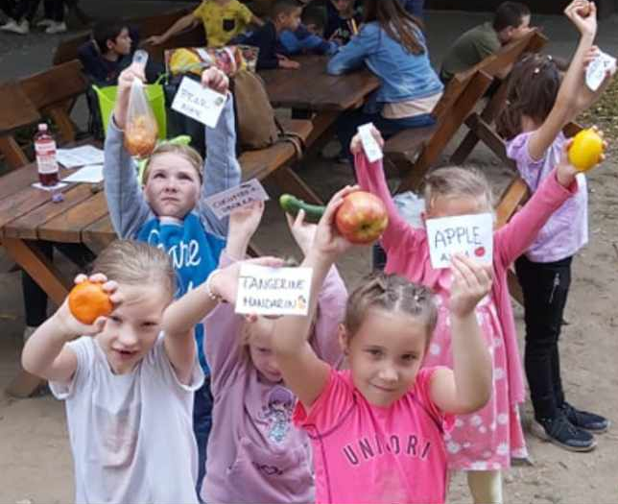
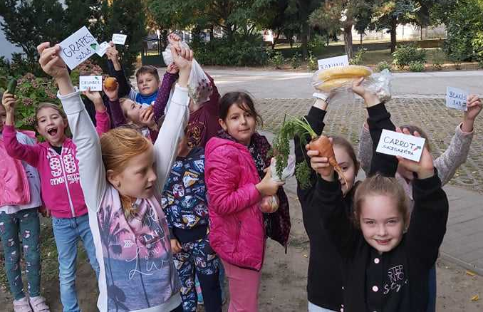

- 29 September: The first week of the Erasmus programme was organised in Croatia from 29 September to 3 October 2021. Three students from our school, Ákos Szabó Lukács (7.b), Zsombor Nagy (8.b), Imre Nagy (8.a) travelled with their teachers Imre Szabó and Flóra Hantos. The programme included a number of theoretical and practical skills competitions for both the students and the teachers. The Croatian participants presented their school and the school delegation had the opportunity to participate in various presentations and performances. During the second half of the week, several excursions were organised by the host country.
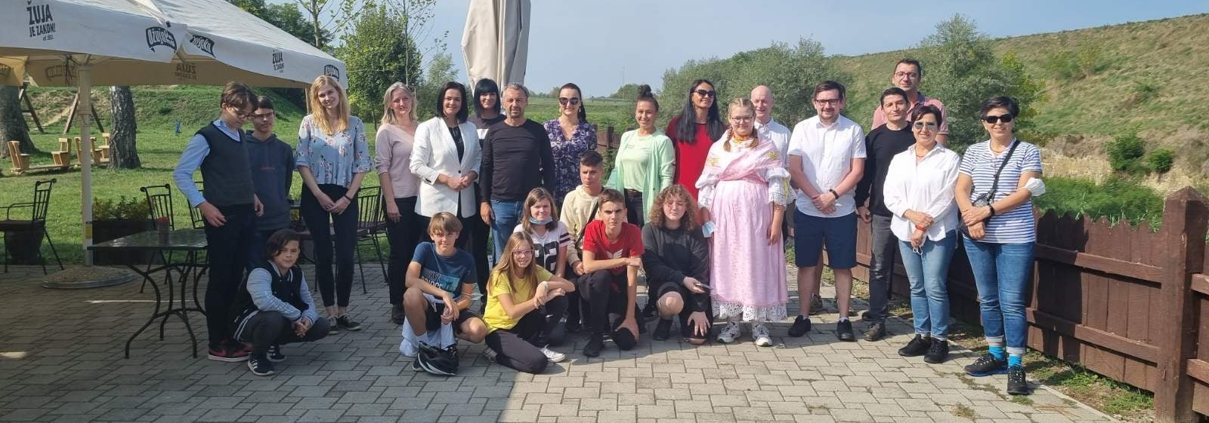

- October:
- October 3: Return from Croatia.

- December:
- During the last English lessons before the winter break, we supplemented the current curriculum with various Christmas-themed activities and quizzes. In addition, Christmas songs were taught in English with the students who attend the bilingual section.

- January:
- January is the time for the mid-term exams in different subjects for each year group. English language exams are given to year 6 and 8 students. The topics of the exam are similar to the oral sections of each language exam, which are related to everyday life and focus on general communication skills. The exam is divided into three main parts: general introduction, topics/communication, description. English is taught in a level-group structure, so the content of the exams varies from group to group, depending on the level of the group.

- March:
- 1 March: Four pupils from our school took part in the 'Pancake Day' organised by the Kossuth Lajos Primary School of Kossuth Lajos Gimnázium, where students were invited to participate in theoretical and practical activities based on English traditions. We finished with a very good result for our school, as the girls achieved a second place. The participants were Boglárka Fábián, Boglárka Nagy, Kira Kiss and Tímea Ugrai.

- 17 March: Call for posters on the theme of environmentally friendly transport.
- 25 March: Farewell of our mother tongue teacher, Paul Rhea Jill by the bilingual classes. The children made drawings and sang songs for Rhea. We also surprised Rhea with a collective farewell gift, a T-shirt signed by all the pupils.
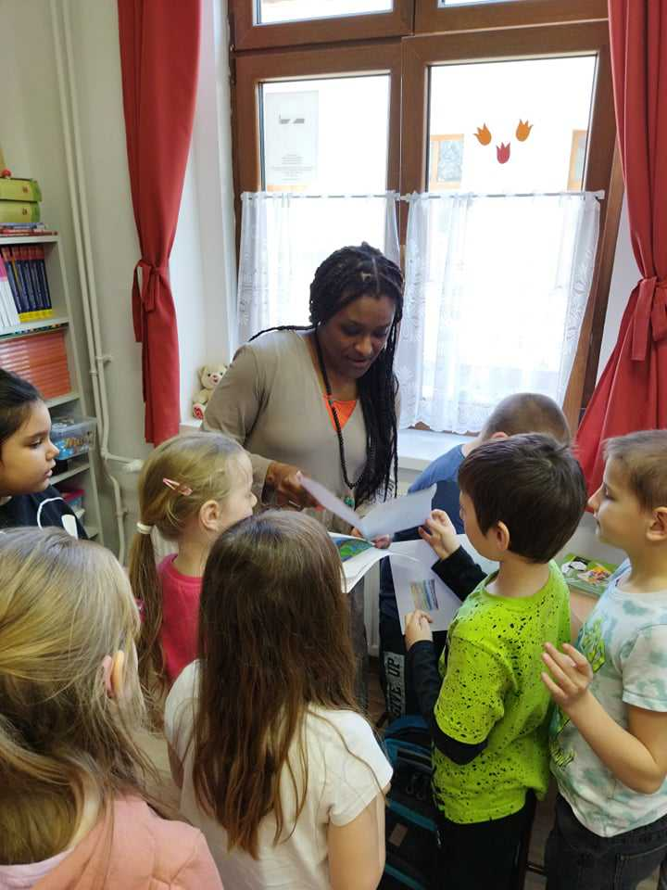
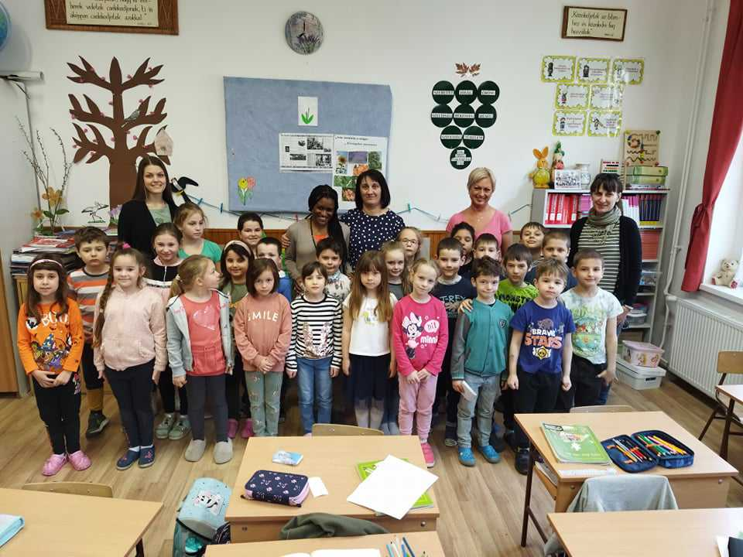
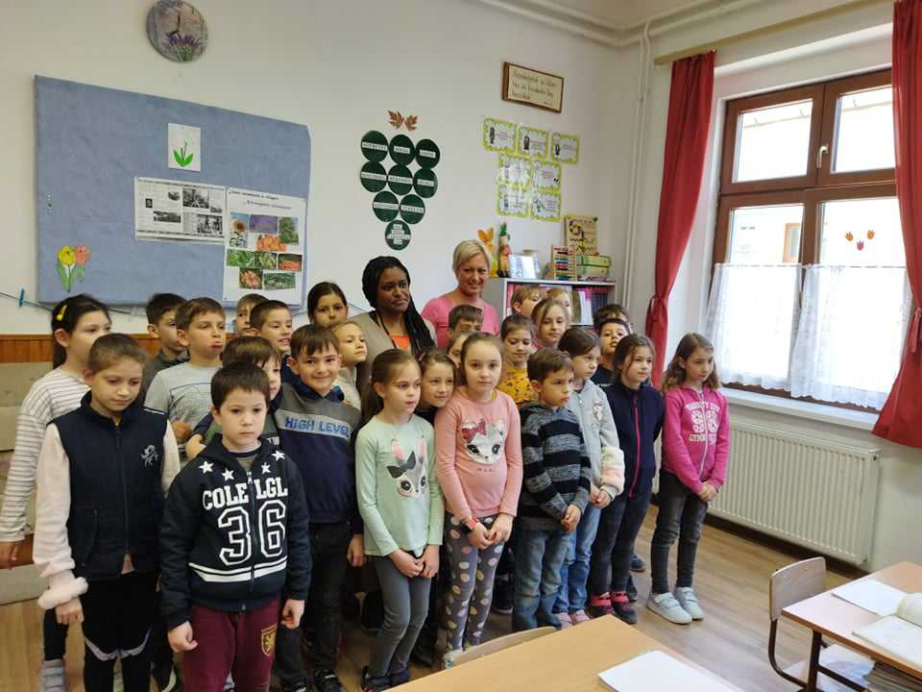
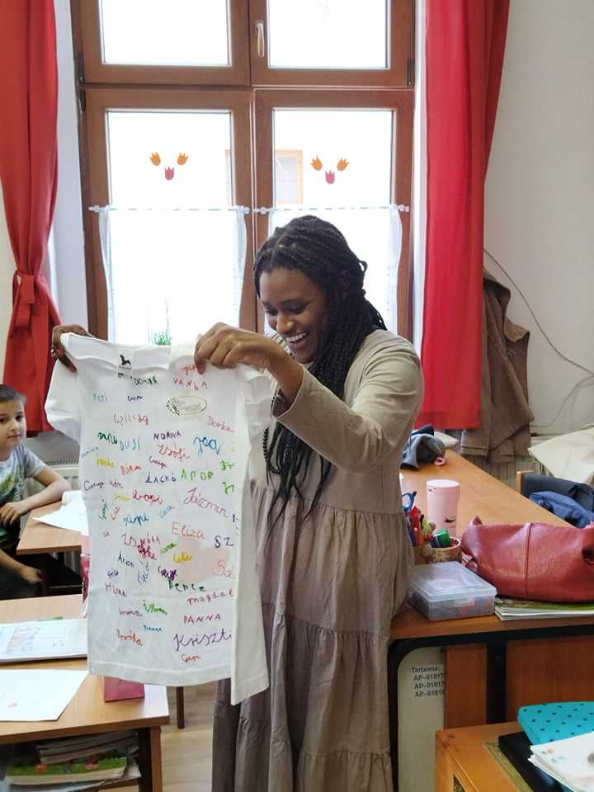
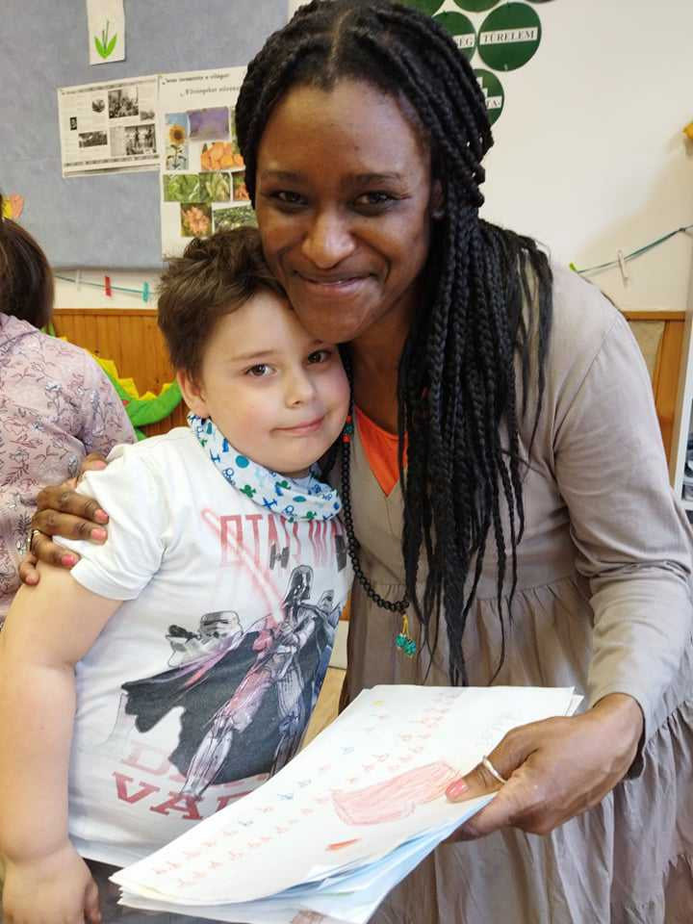

- March 30: Another mother tongue tutor, Eszter Rusznyák came to us, who gave online English lessons to our bilingual students until the end of the school year.
- 30 March: Exhibition of posters and drawings on the theme of environmentally friendly transport in the gym. All classes were able to see the drawings and posters made by their classmates.
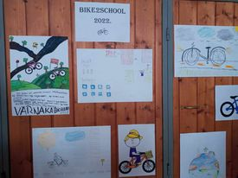

- 28 March - 1 April: As the part of the Erasmus application our school hosted the programme for a week. Unfortunately, due to the virus situation and the outbreak of the Ukrainian-Russian war, the programmes were only held online. On the opening day on Monday and on the closing day on Friday, the eighth-graders of our school presented a short English-language programme. The countries participating in the programme are Croatia, Northern Ireland, Turkey and Hungary.

- April:
- 1 April: The Erasmus programme week in Tiszafüred closed.

- 7 April: Our school held an open day where parents could visit the English language classes.
- Pre-spring break English language activities and games on the theme of Easter in English language classes.

- Creative works were made in the technique and fire enamel classes in the framework of the Erasmus Bike2school programme. The name of the programme means that most of the works depict bicycles.

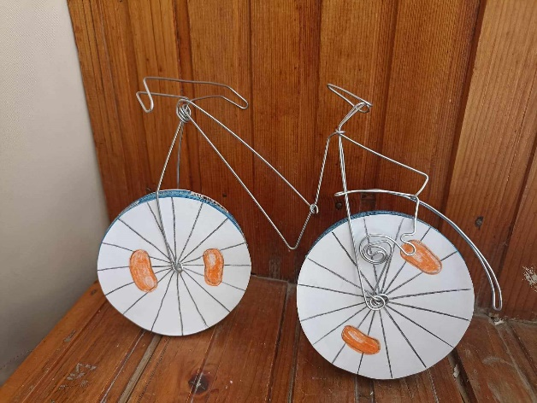
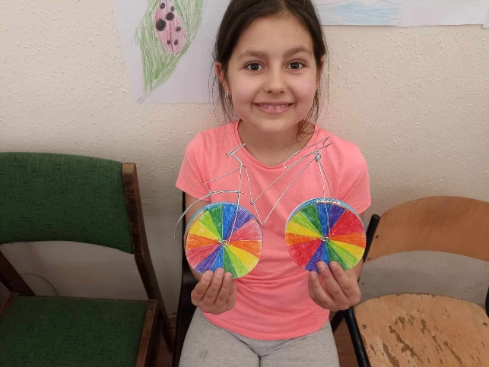

- Decorating bicycles for Easter in the framework of the Erasmus programme.
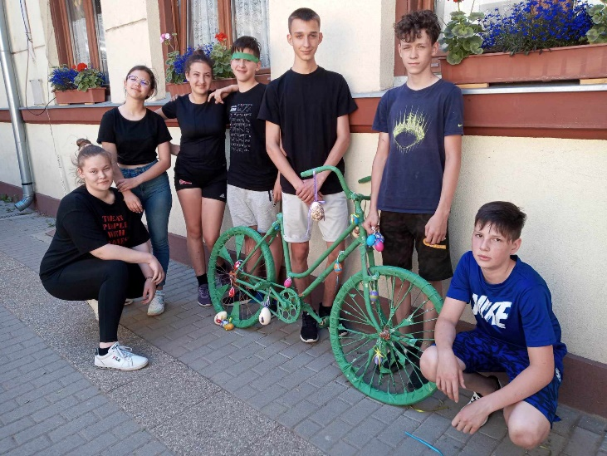

- May:
- Start of end-term exams: in English in grades 6 and 8, in the same way as the mid-term exams.
- In May, pupils watched educational videos in English and Hungarian on the importance of cycling correctly. In connection with the same theme, pupils had the opportunity to create awareness-raising posters about alternative means of transport. After the poster creation activity, the pupils in the cycling group were able to try out the different means of transport at school.
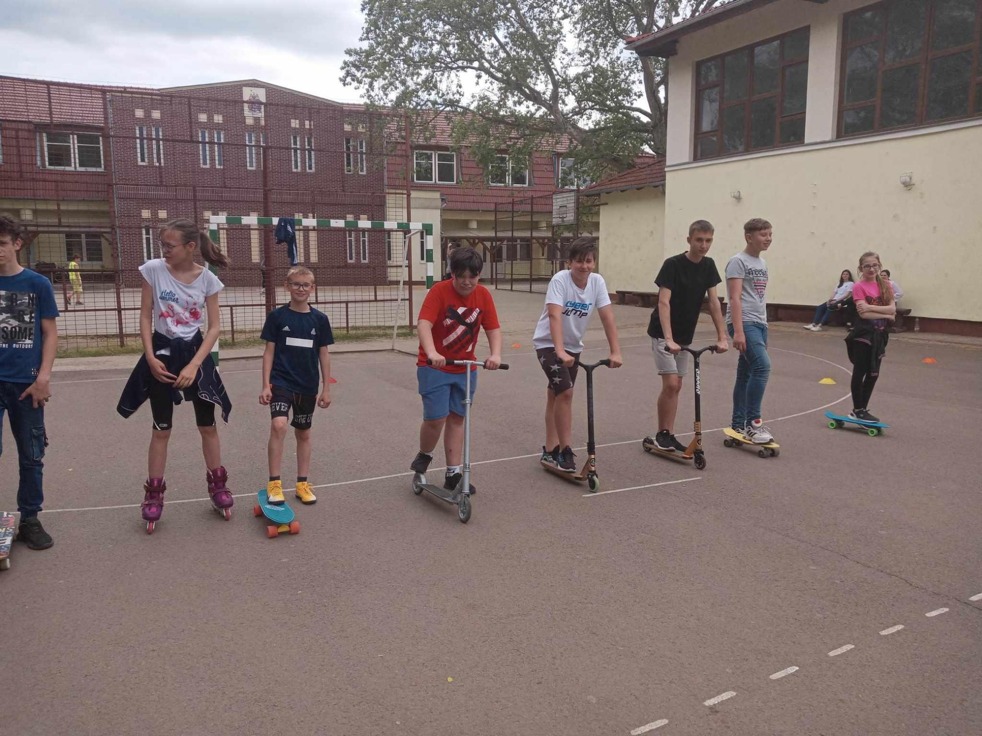
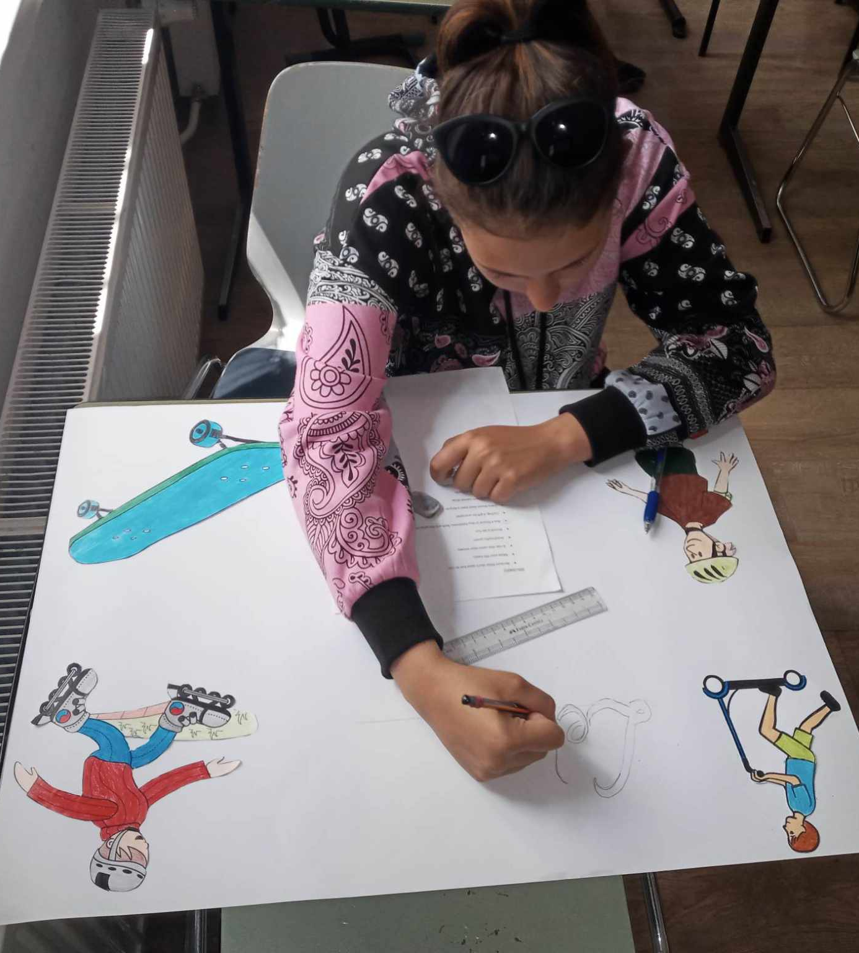
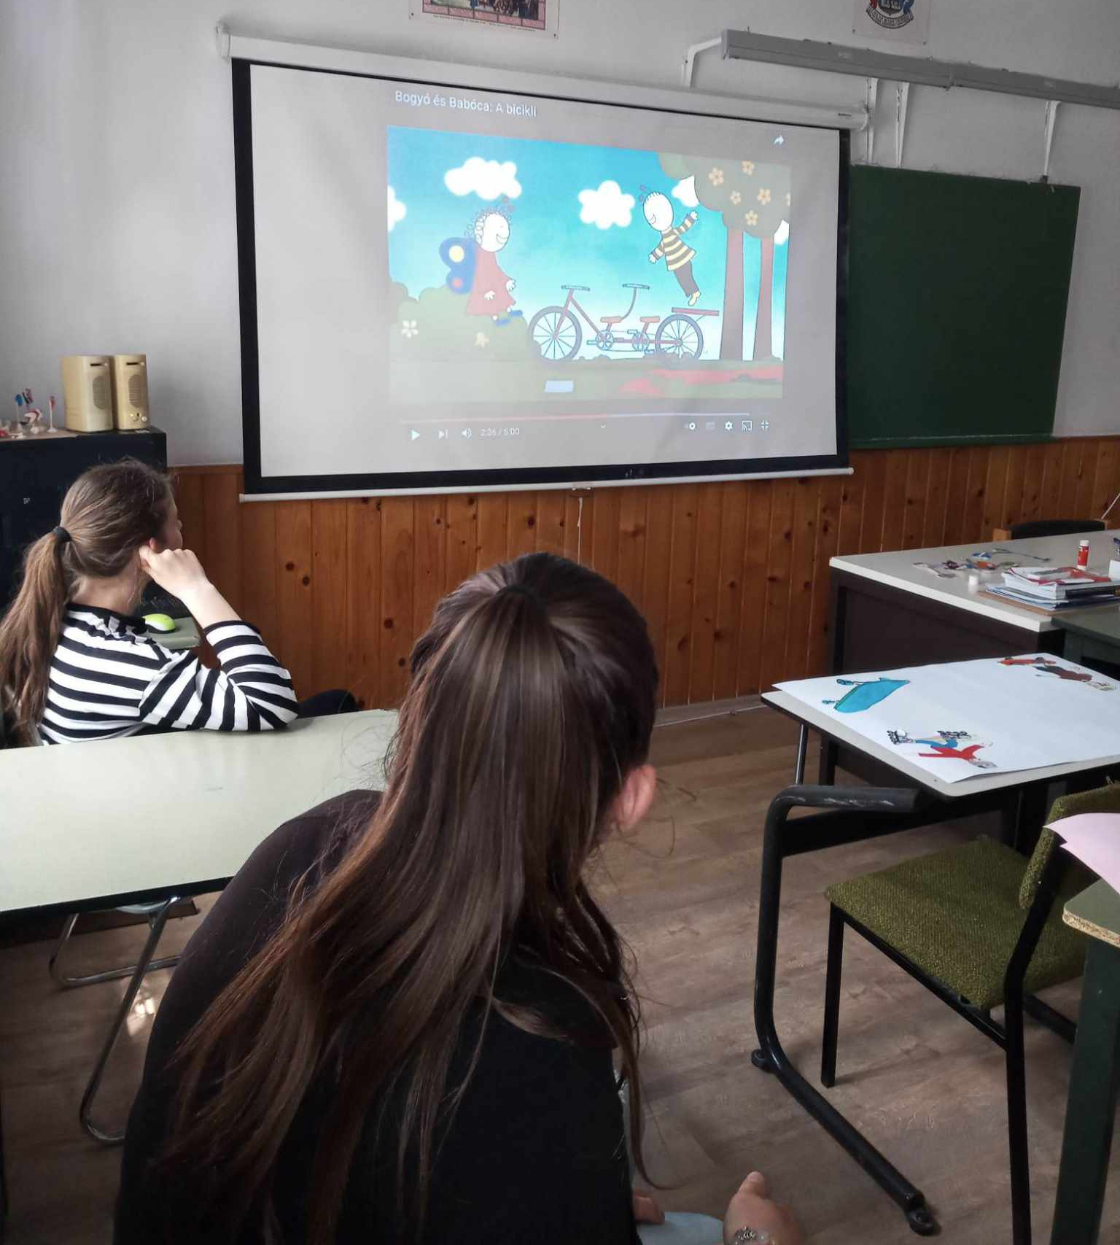

- 26 May: The Europe Day competition, originally on 9 May, was held in our school on 26 May in the spirit of "peace and unity". Pupils from Years 7 and 8 took part in the quiz, where the first three winners were awarded prizes. The tasks and activities included: a knowledge test, a 'Peace and Unity' drawing competition, a 'Tastes of Europe' buffet and a football match.
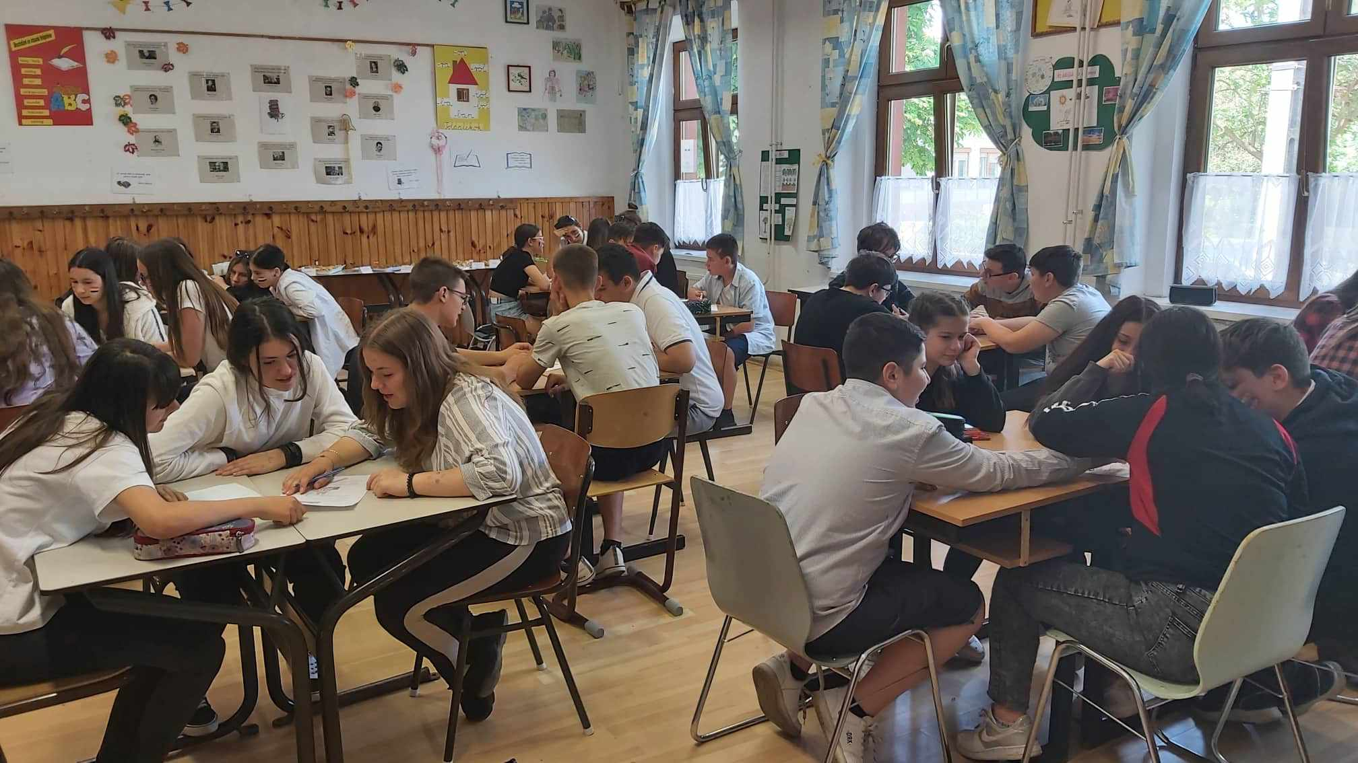

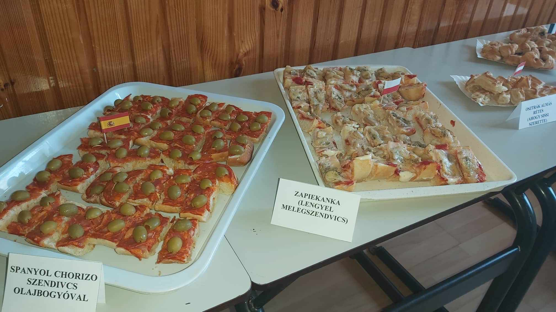
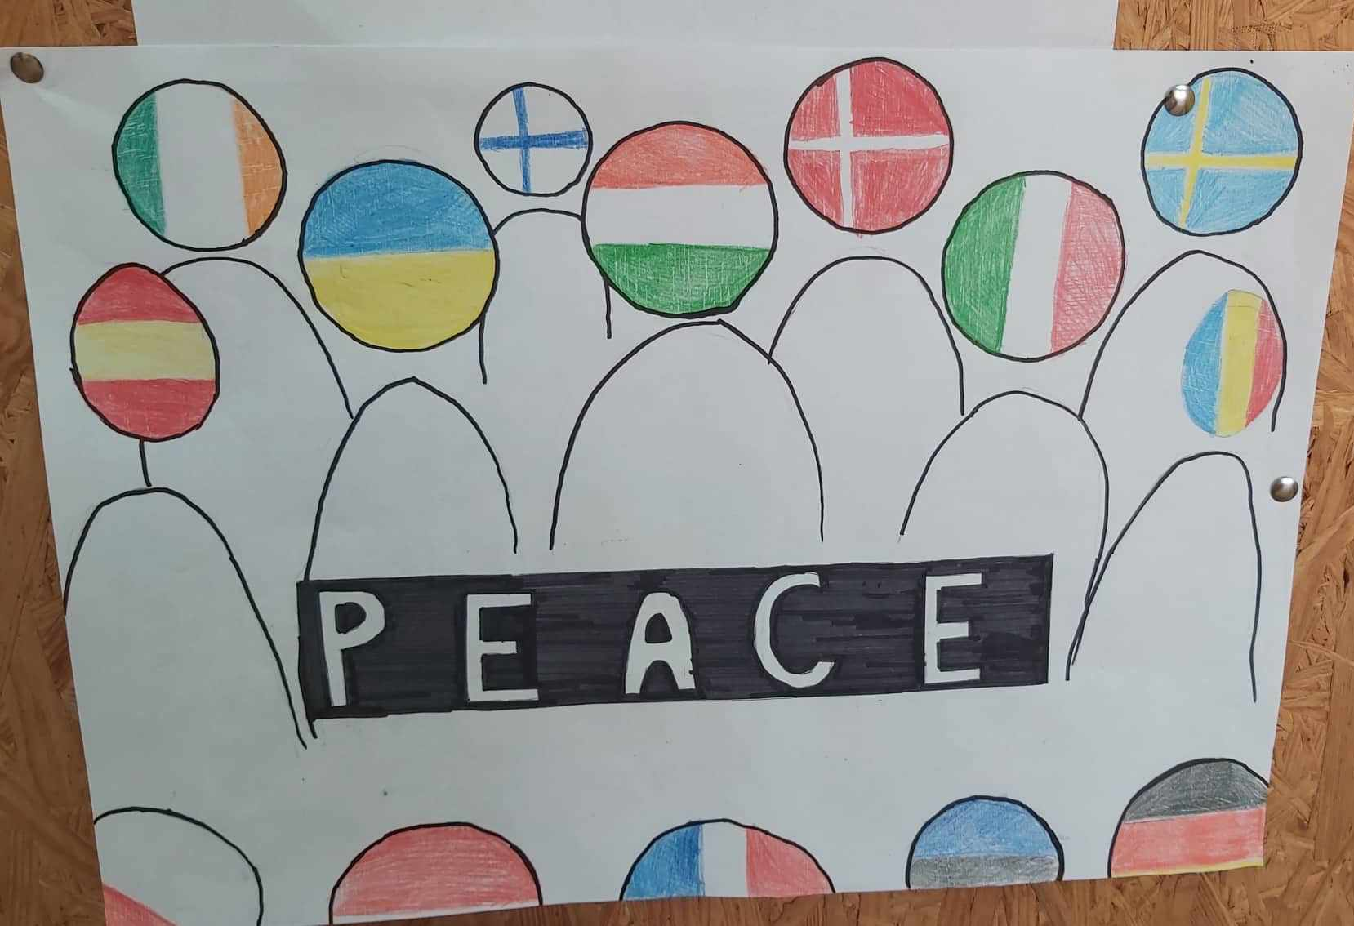

- June:
- June 6 - 11: Turkey hosted the programme between 6 June and 11 June 2022, where Flora Hantos and Klaudia Ale travelled to represent our school. The first day was a visit to the base institution in Antalya, where each participating country presented the activities carried out in their school, as required by the programme. The presentations were followed by a short reception. On the same day, there was a visit to the Mayor of the city for a short discussion. In the afternoon, an environmental kindergarten was presented, where children worked with natural and recyclable materials. Several cycling activities were organised by the host school. The second half of the week was all about hiking and tours. In the last days the main details of the next meeting were agreed.

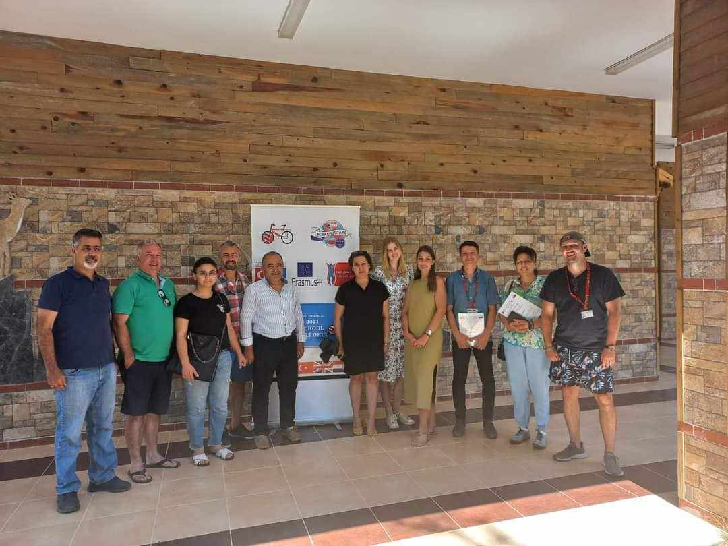
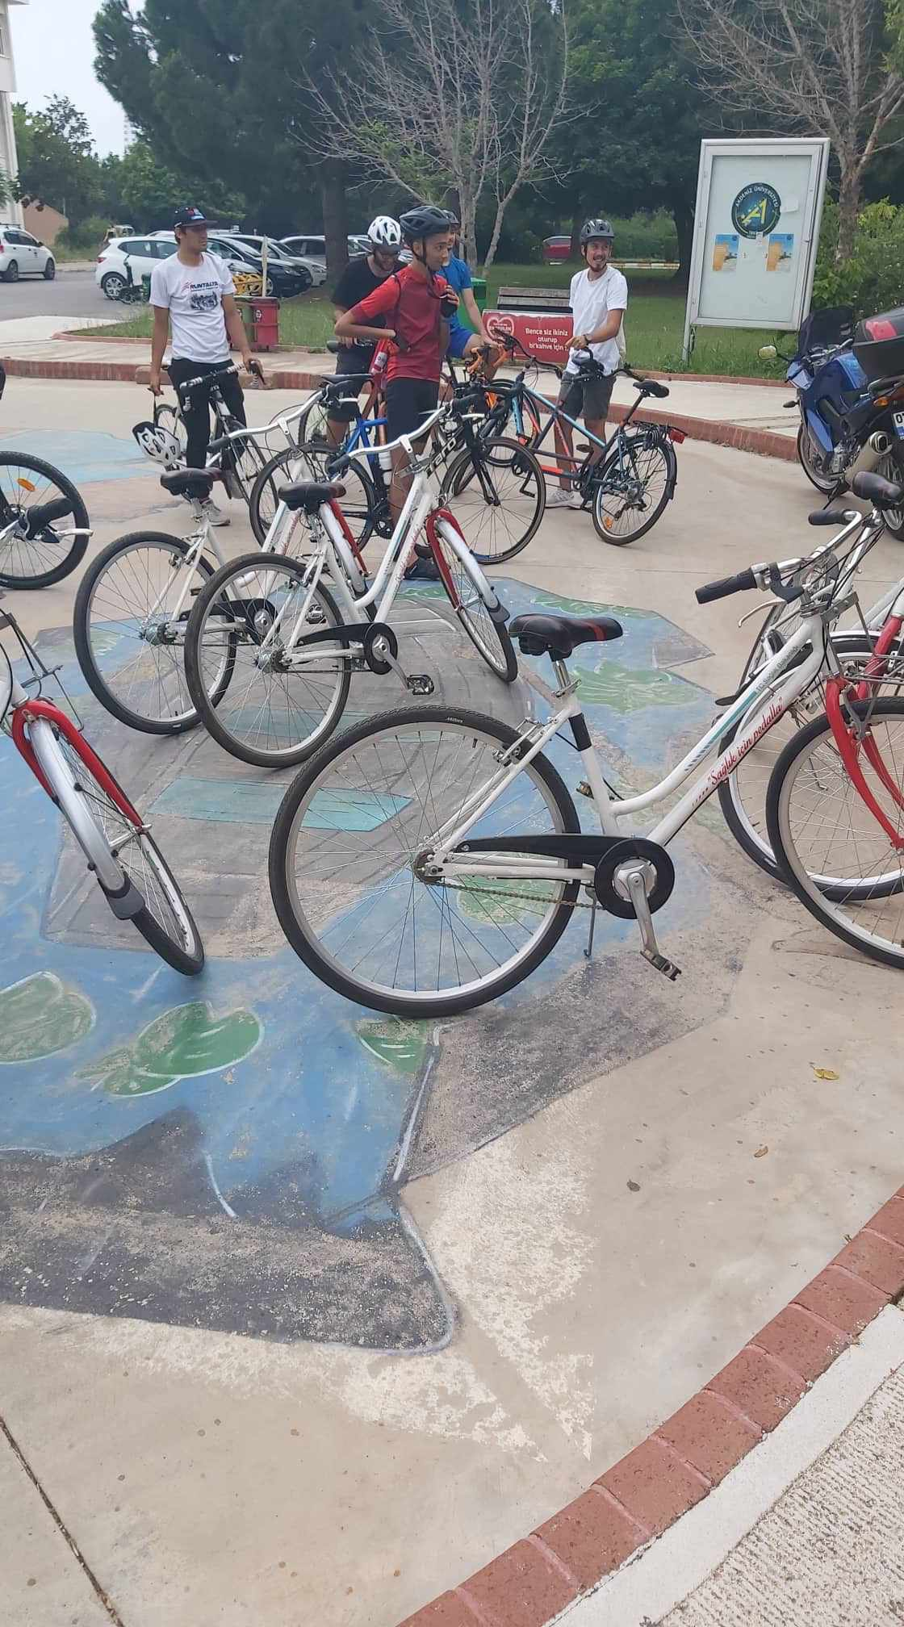
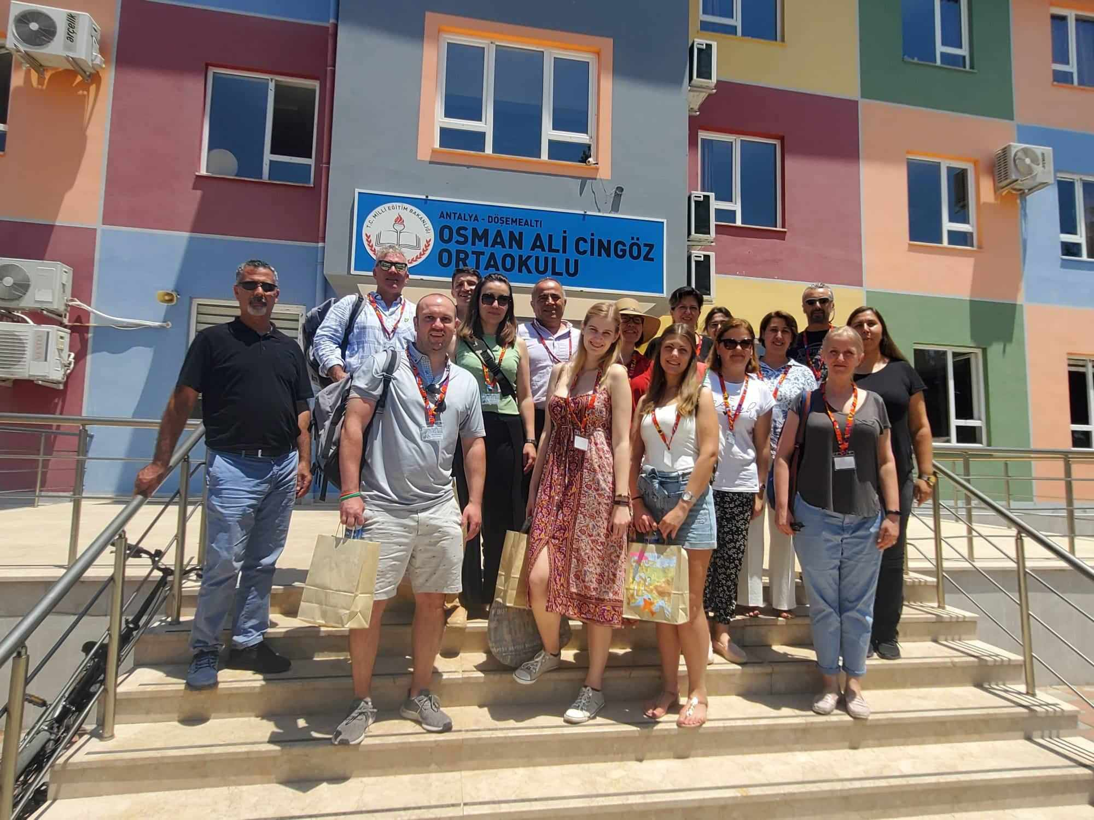

- 13 June: Students’ Government Day: Painting and decorating unused bicycles. Pictures of the event were presented in English in Northern Ireland.
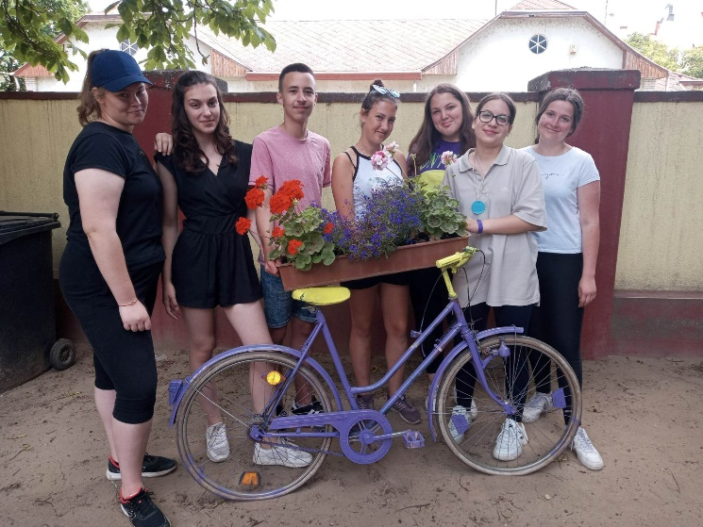
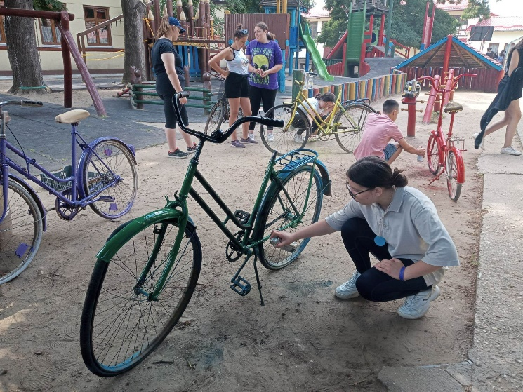

- 14 June: Children's Day: Children completed tasks at different stations. At the English language station, pupils were given theoretical and creative tasks on vegetables and
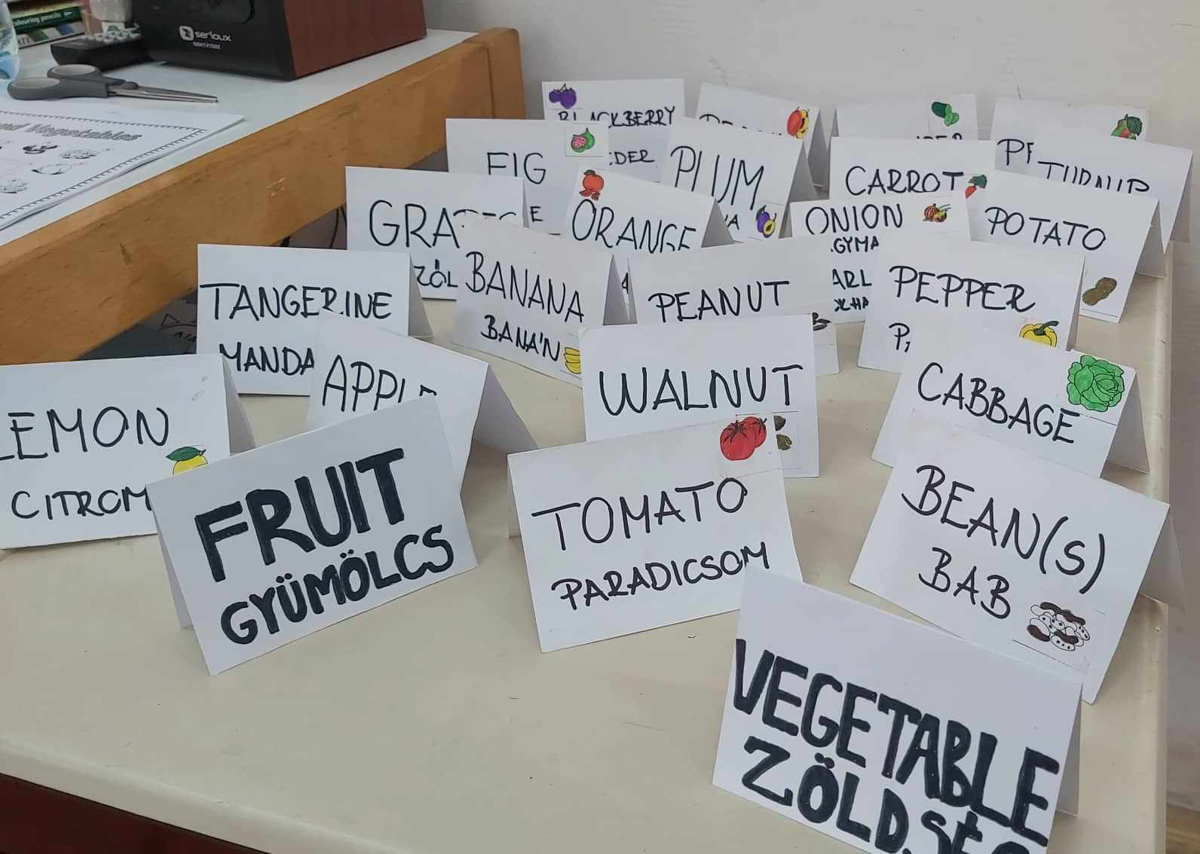
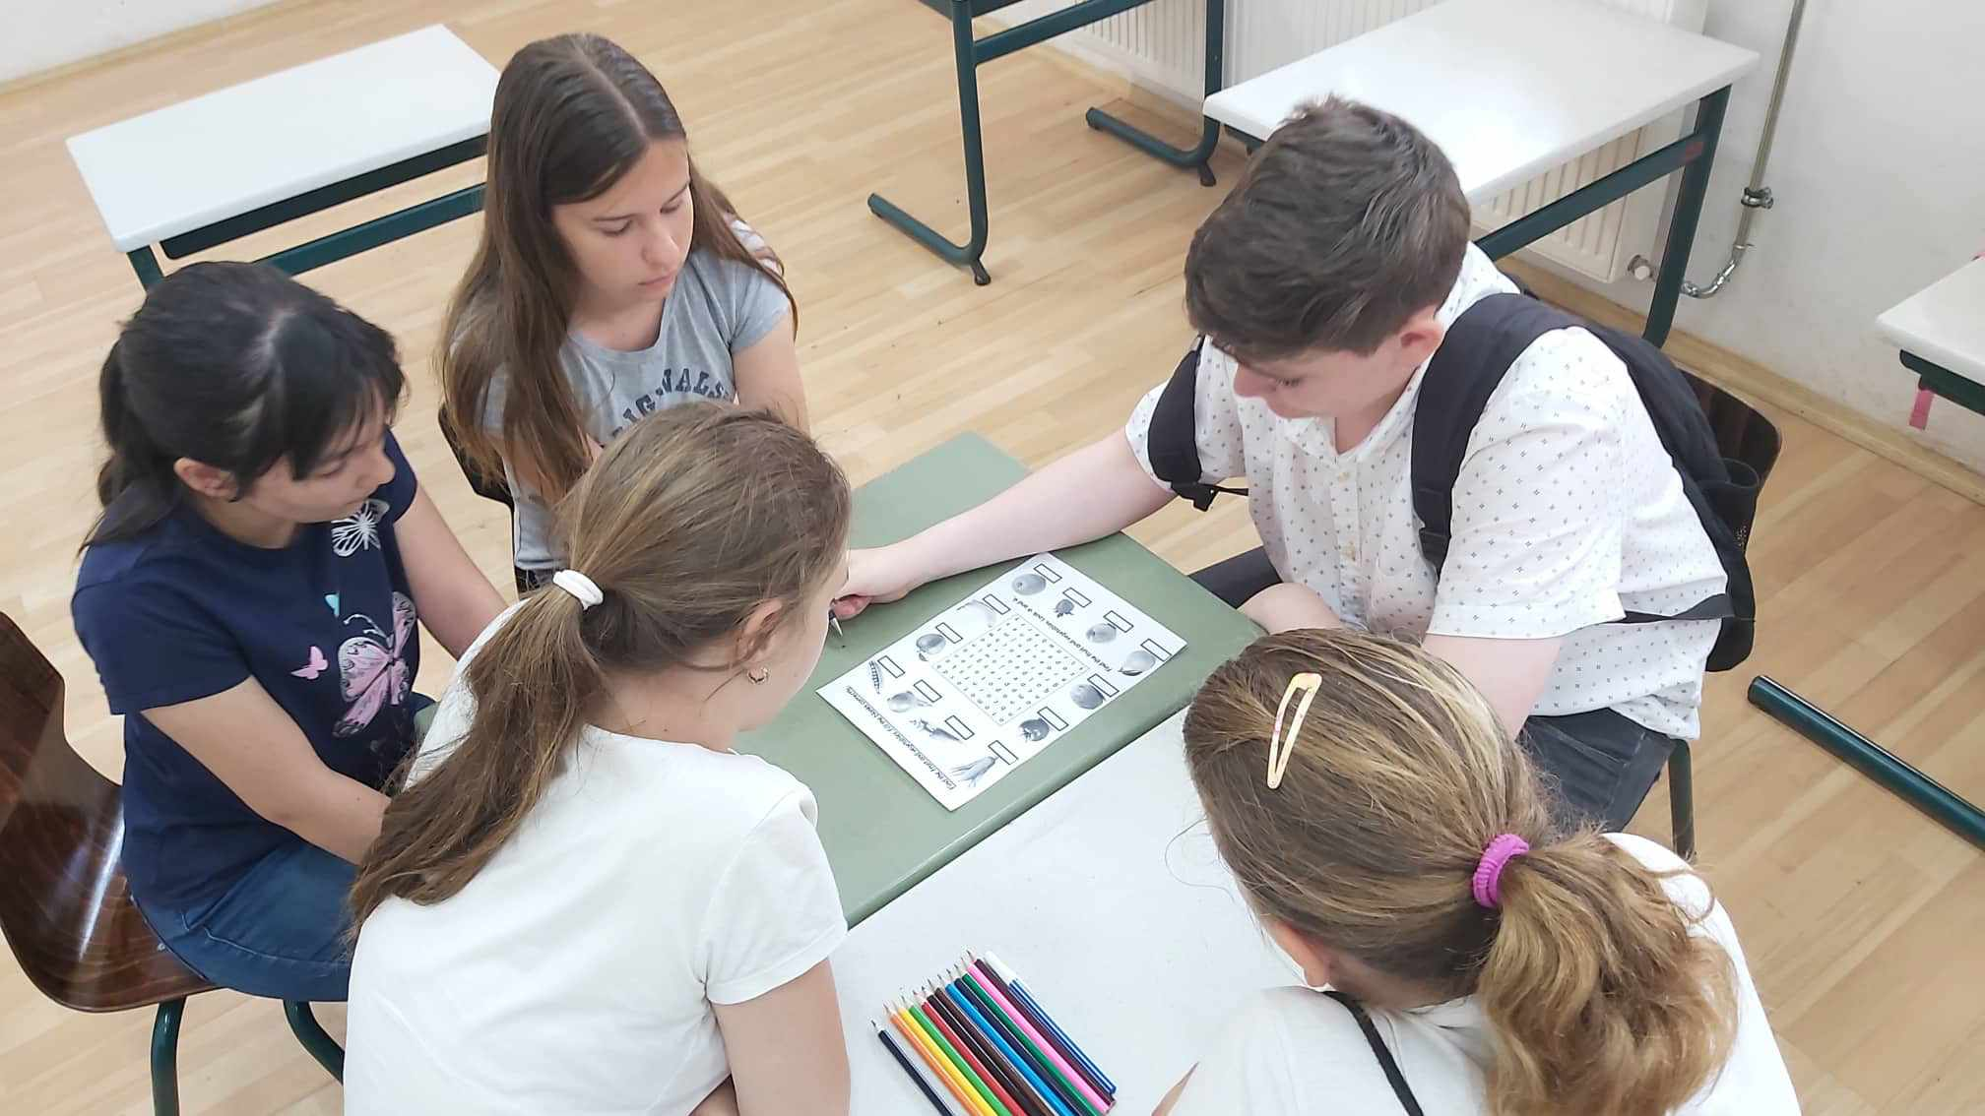
fruit.

- 14 June: ‘REFI’ Cycling: a bike ride to Poroszló led by the pastor Sándor Konrád Szabó.
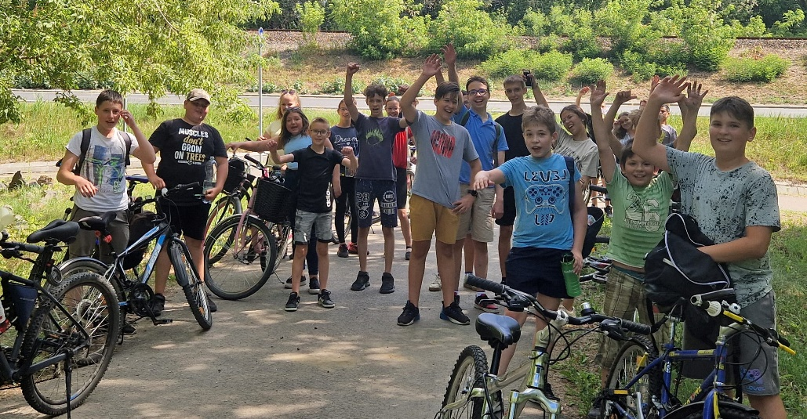

- 27 June - 1 July: The week of programmes in Northern Ireland with the participation of Sándor Konrád Szabó, Zsuzsanna Szabóné Varkoly and Flora Hantos. The activities of the Childrens’ Government Day and the Children's Day organised by the school were presented in English during the week of the meeting. The rest of the week, as in previous meetings, was spent on an excursion. It was a successful closing of the programme.

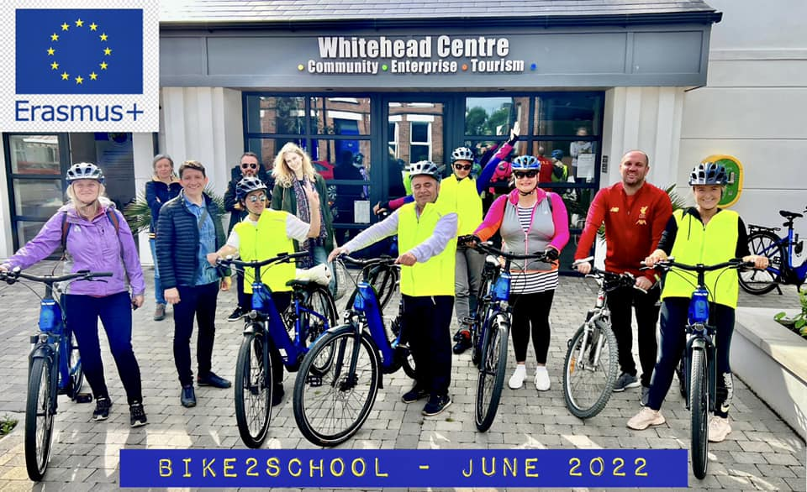
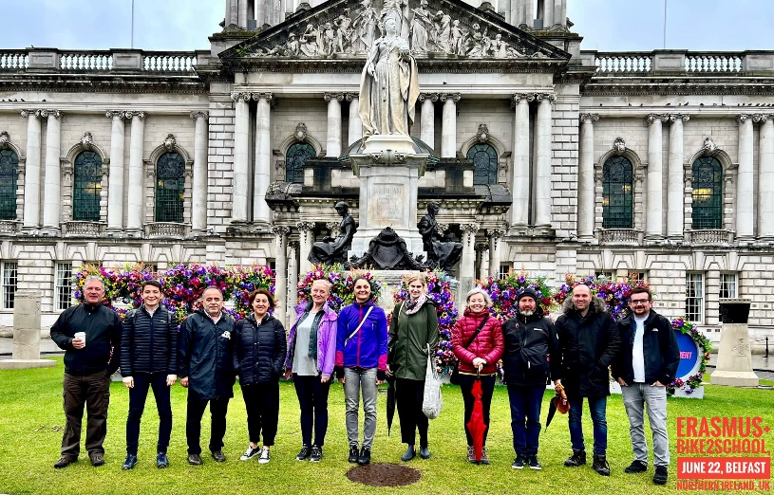

- July:
- 11- 15 July: English Freshers' Camp: The English Freshers' Camp was organised by English teachers for our future first-graders who will start their bilingual studies in September. The main aim of the camp was for the children to get to know each other and their future teachers and to learn the basics of English. A new topic was explored in a playful way every day. We learned new words and phrases through songs, sayings and playful exercises. By the end of the week, we had learned to introduce ourselves in English, count, name different colours, vegetables, fruits, animals and toys.
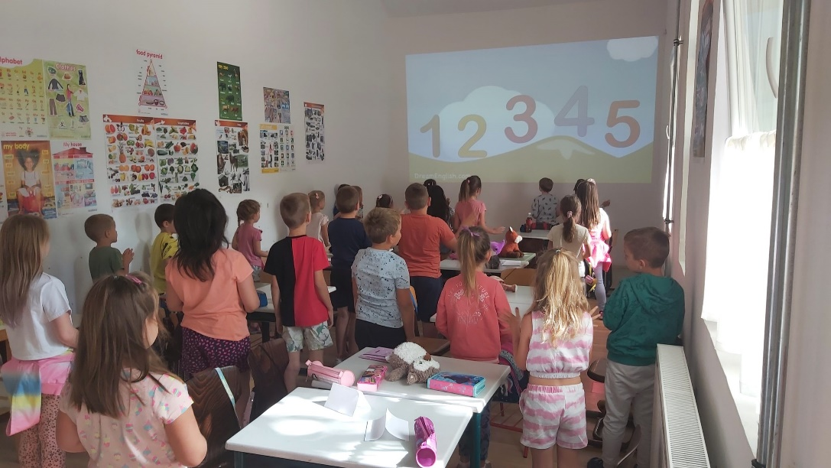

- 25 - 29 July: Healthy Lifestyle Camp: The aim of the camp was to teach children the basics of a healthy lifestyle, both in terms of nutrition and exercise. Each morning started with gymnastics or zumba. Mornings were spent with creative drawing activities and worksheets. The activities were related to healthy living. The afternoons were spent in the gym, where the children could play, dance, talk, draw and even play ball games. For lunch and snack we had cereal, cereal, yoghurt, fruit and vegetable salad with different dressings. We made fruit smoothies several times during the week, using a variety of fruit.
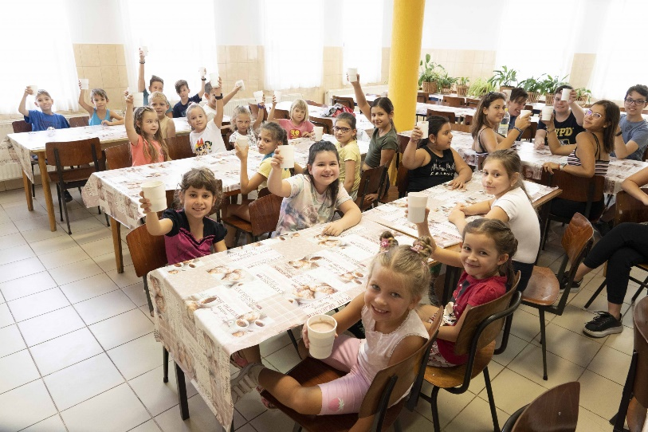
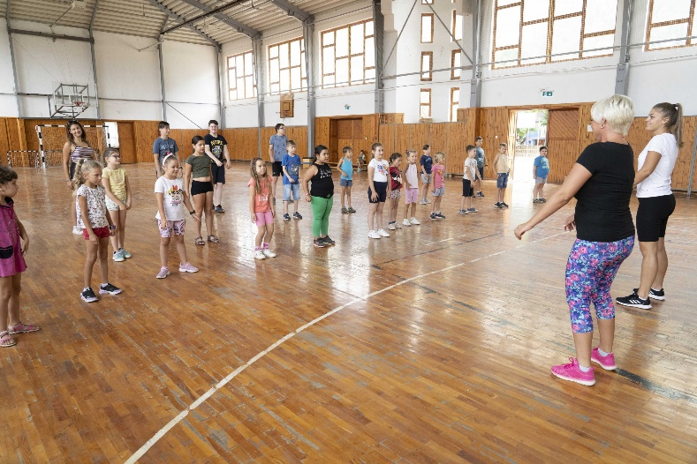

- August:
- August 1 - 5: Reading and English Camp: Students were introduced to different stories and interesting readings, and then made creative works related to them. The children were given the opportunity to deepen their language skills through English language games. On Friday we closed with an exciting quiz.


